**Assignment: Chinook Sample Databases Setup**

**Prathamesh Verlekar**

**NUID: 001376578**

**MySQL - sales (via invoiceline) by genre name**

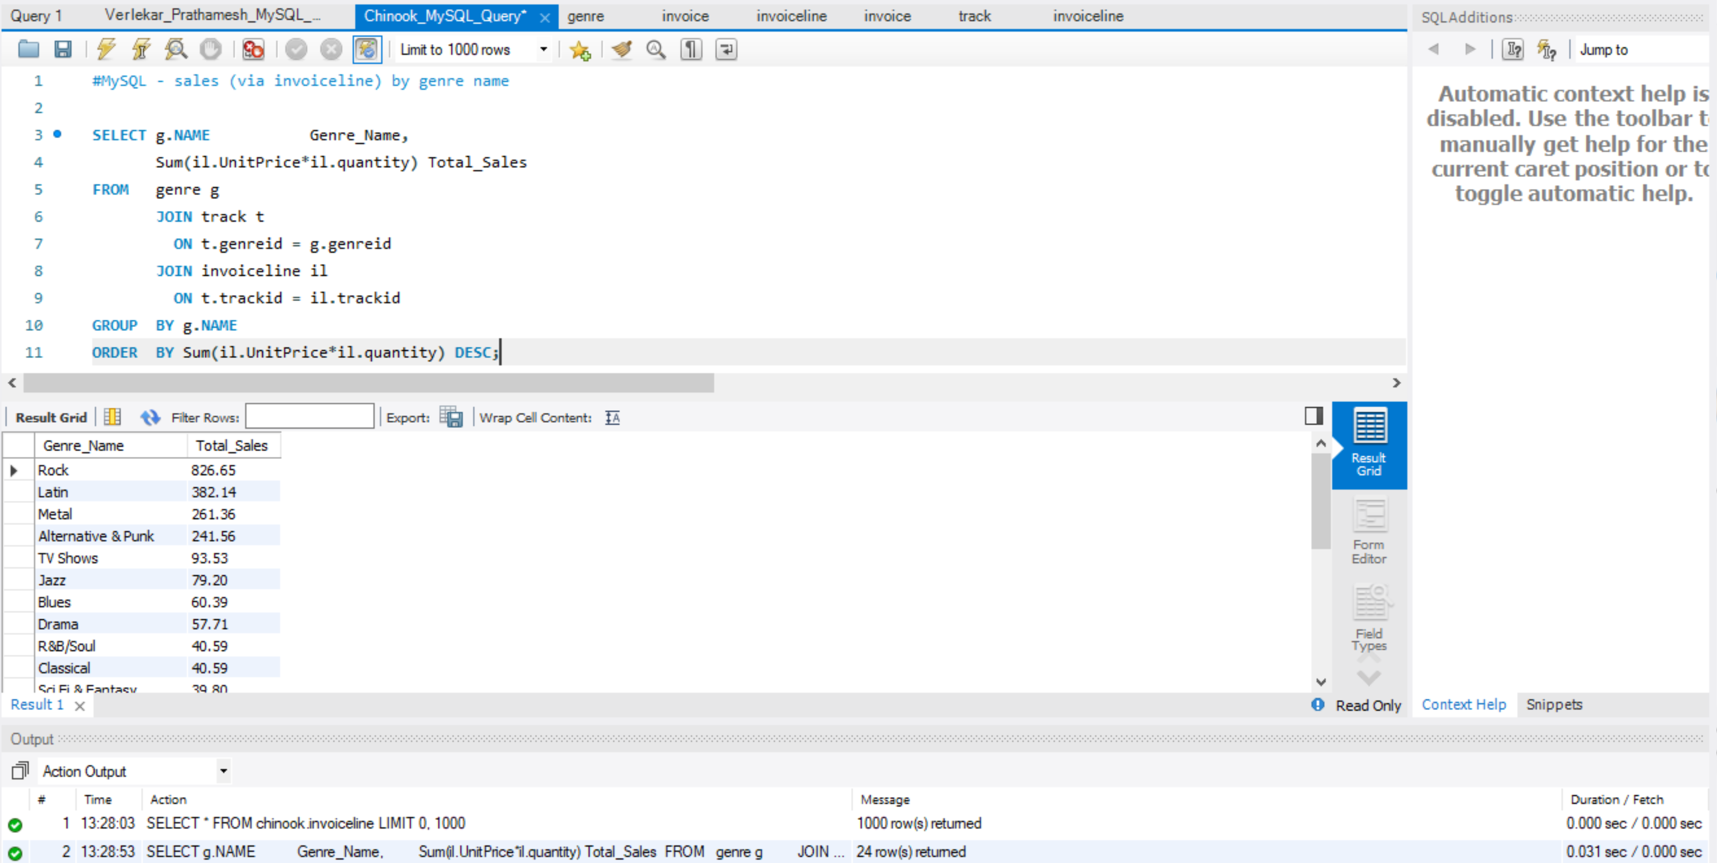

**SQL Server -  top 20 by customer (lastname & first name) sales (via invoiceline)**

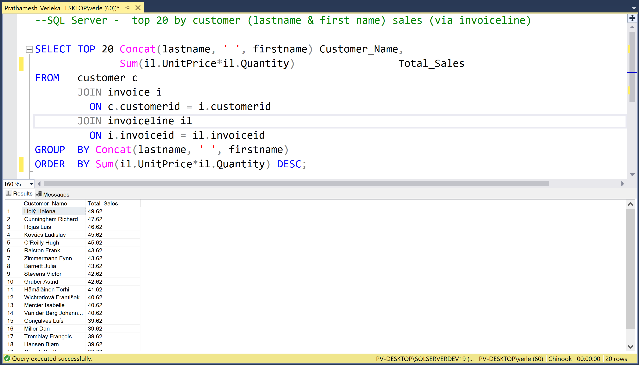

**PostgreSQL - Top 10  album (title) sales (via invoiceline)**

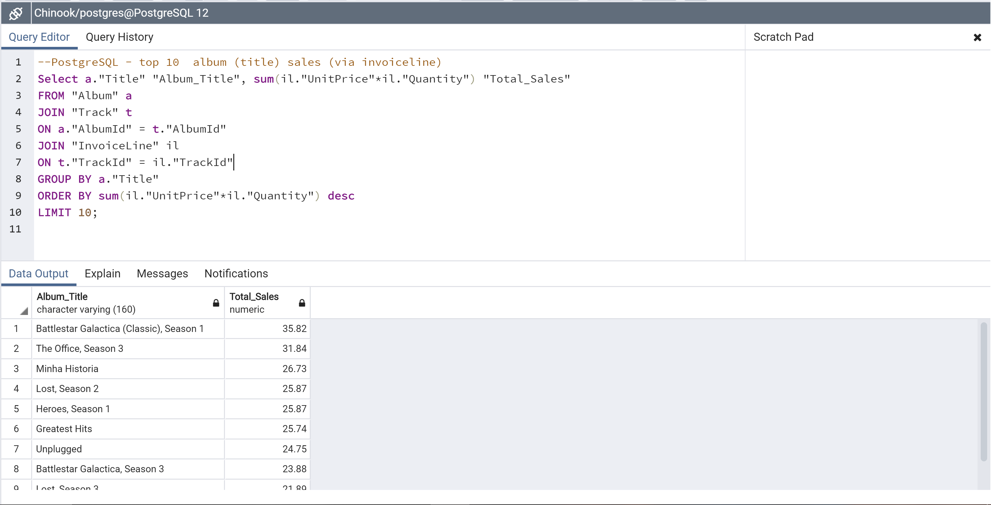

**Oracle - sales total by Billing Country**

